Assessment: Exercise 03

Student Name: Vedant Goswami

Lab Professor Name: Mel Sanschagrin

Section Number: 321

Due Date: 24/6/2022

Understand the problem,

* In brief, I will need to make a program for school that can calculate the Hypotenuse, perimeter, and the area of right-angle triangle using the given input of adjacent and opposite sides. The class, methods and constructors will be based on ULM diagram made by another programmer.
* And the result should be in 4 decimal points ( To achieve that the format method will be used).
* The needed formulas will be :-

Hypotenuse²= Adjacent² + Opposite side²

Perimeter = Hypotenuse+Adjacent+Opposite side

Surface area = (Adjacent* Opposite side)*0.5.

# Pseudocode for calculateHypotenuse method:

claculateHypotenuse()

num hypotenuse

num adjacentSqr

num oppositeSqr

adjacentSqr = Math.pow(adjacent, 2)

oppositeSqr= Math.pow(opposite, 2)

hypotenuse = Math.sqrt ( adjacentSquared + oppositeSquared )

return hypotenuse

# Pseudocode for calculate Perimeter method:

calculateperimeter(){

num hypotenuse

num perimeter

perimeter = hypotenuse + adjacent + opposite

return perimeter,

}

# Pseudocode for calculateArea method:

calculateArea(){

Declaration

num area

area =(opposite side + adjacent)*(0.5)

return area }

# Pseudocode for Report method:

creatReport()

declaration

string report

format all to 4 digit

print “Adjacent:”

print “opposite:”

print “Hypotenuse:”

print “Perimeter:”

print “Area:”

stop

# Pseudocode for main method:

Declaration

num adjacent

num opposite side

import scanner

print “Enter the length of opposite side:”

print “Enter the length of Adjacent side:”

hypotenuse = triangle.calculateHpotenuse()

perimeter = triangle.calculatePerimeter()

area = triangle.calculateArea()

report = triangle.createReport(

hypotenuse = triangle.calculateHpotenuse()

perimeter = triangle.calculatePerimeter()

area = triangle.calculateArea()

report = triangle.createReport(

hypotenuse = triangle.calculateHpotenuse()

perimeter = triangle.calculatePerimeter()

area = triangle.calculateArea()

report = triangle.createReport(

hypotenuse = triangle.calculateHpotenuse()

perimeter = triangle.calculatePerimeter()

area = triangle.calculateArea()

report = triangle.createReport(

hypotenuse = triangle.calculateHpotenuse()

perimeter = triangle.calculatePerimeter()

area = triangle.calculateArea()

report = triangle.createReport(

rt

output "Hypotenuse: " + hypotenuse // format to 4 decimal places

output "Perimet

hypotenuse = triangle.calculateHpotenuse()

perimeter = triangle.calculatePerimeter()

area = triangle.calculateArea()

report = triangle.createReport(

hypotenuse = triangle.calculateHpotenuse()

perimeter = triangle.calculatePerimeter()

area = triangle.calculateArea()

report = triangle.createReport(

hypotenuse = RightAngleTriangle.calculateHpotenuse()

perimeter = RightAngleTriangle.Perimeter()

area = RightAngleTriangle.calculateArea()

report = triangle.createReport()

print report

print “program by vedant goswami

stop

# FlowChart :

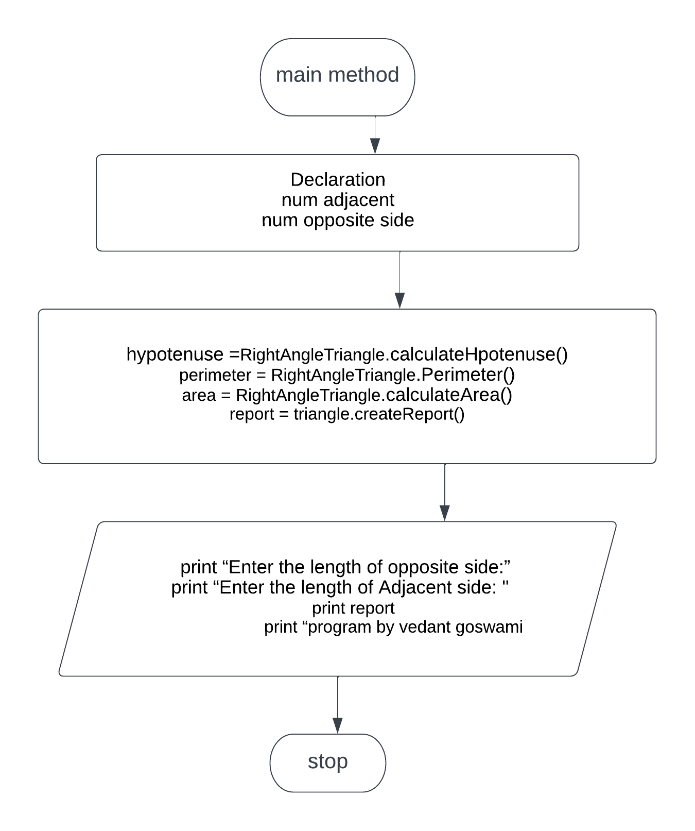

Name: Vedant Goswami

(Note refer to ULM diagram for further details)

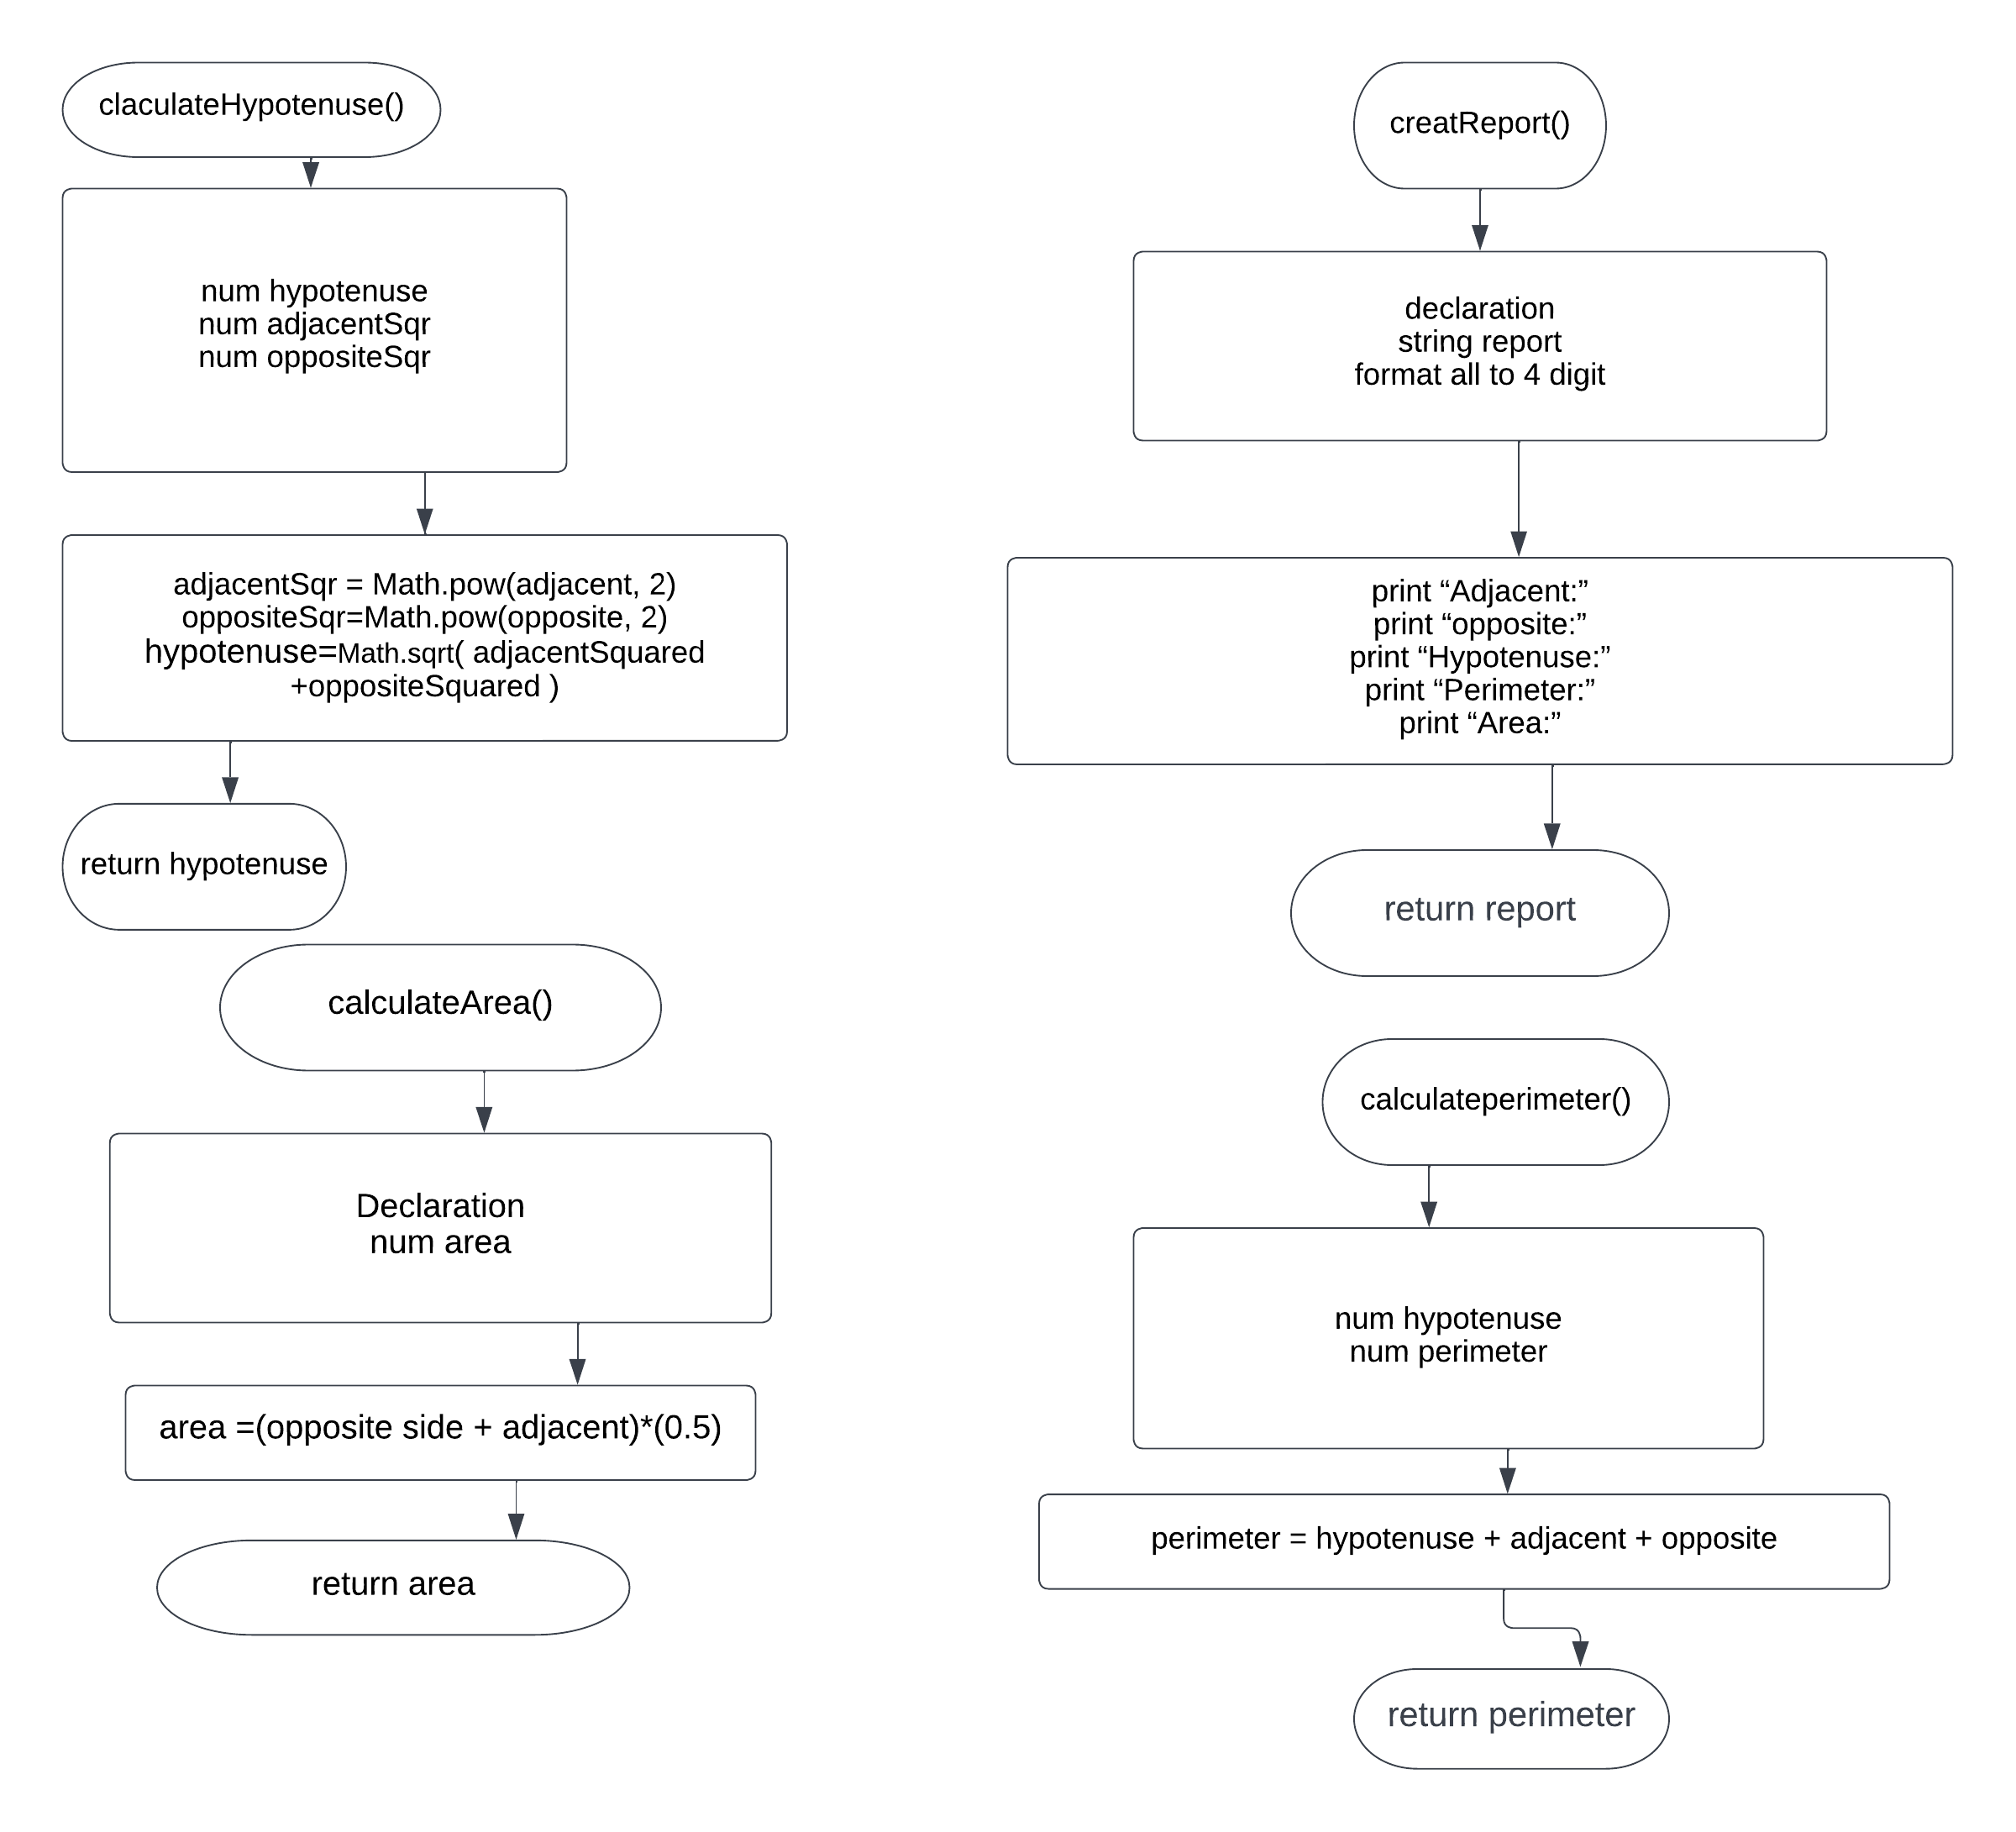

# Algorithm test plan:

|  |  |  |  |
| --- | --- | --- | --- |
| Input | Expected outcome | Actual outcome | Description |
| 11,12 | Adjacent 11.0  Opposite 12.0  Hypotenuse 16.2788  Area 11.5000  perimeter 39.2788 | Adjacent 11.0  Opposite 12.0  Hypotenuse 16.2788  Area 11.5000  perimeter 39.2788 | Algorithm test plan Expected outcome of program matches the actual come. |
| -11,12 | Adjacent-11.0  opposite12.0  Hypotenuse 16.2788  Area 0.5000  perimeter 17.2788 | Adjacent-11.0  opposite12.0  Hypotenuse 16.2788  Area 0.5000  perimeter 17.2788 | Algorithm test plan Expected outcome of program matches the actual come.(  Note the values are calculated using a calculator) |

# Screenshot of running program:

# Program test plan:

|  |  |  |  |
| --- | --- | --- | --- |
| Input | Expected outcome | Actual outcome | Description |
| 11,12 | Enter the lenght of adjacent  11  Enter the lenght of oppposite side  12  Adjacent11.0  opposite12.0  Hypotenuse 16.2788  Area 11.5000  perimeter 39.2788 | Enter the lenght of adjacent  11  Enter the lenght of oppposite side  12  Adjacent11.0  opposite12.0  Hypotenuse 16.2788  Area 11.5000  perimeter 39.2788 | Expected out-put of program matches the actual programs output. |
| -11,12 | Enter the lenght of adjacent  -11  Enter the lenght of oppposite side  12  Adjacent-11.0  opposite12.0  Hypotenuse 16.2788  Area 0.5000  perimeter 17.2788 | Enter the lenght of adjacent  -11  Enter the lenght of oppposite side  12  Adjacent-11.0  opposite12.0  Hypotenuse 16.2788  Area 0.5000  perimeter 17.2788 | Expected out-put of program matches the actual programs output. |
| vedant | Error | Enter the lenght of adjacent  vedant  Exception in thread "main" java.util.InputMismatchException  at java.base/java.util.Scanner.throwFor(Scanner.java:939)  at java.base/java.util.Scanner.next(Scanner.java:1594)  at java.base/java.util.Scanner.nextDouble(Scanner.java:2564)  at Exercise3.main(Exercise3.java:12) | As expected the values are expected to be in numerical value so the strings give error |

nput Expected output Actual output Description

4

5

adjacent 4.0000, opposite 5.0000,

hypotenuse 6.4031

Hypotenuse: 6.4031

Perimeter: 15.4031

Area: 10.0000

Program by Stanley Pieda

adjacent 4.0000, opposite 5.0000, hypotenuse

6.4031

Hypotenuse: 6.4031

Perimeter: 15.4031

Area: 10.0000

Program by Stanley Pieda

Hand trace of

program logic

produces expected

results

-4

5

adjacent -4.0000, opposite 5.0000,

hypotenuse 6.4031

Hypotenuse: 6.4031

Perimeter: 7.4031

Area: -10.0000

Program by Stanley Pieda

adjacent -4.0000, opposite 5.0000, hypotenuse

6.4031

Hypotenuse: 6.4031

Perimeter: 7.4031

Area: -10.0000

Program by Stanley Pieda

Hand trace of logic

with a negative

number still

produces expected

results, (raising a

negative number to

power of 2 results in

positive number)

nput Expected output Actual output Description

4

5

adjacent 4.0000, opposite 5.0000,

hypotenuse 6.4031

Hypotenuse: 6.4031

Perimeter: 15.4031

Area: 10.0000

Program by Stanley Pieda

adjacent 4.0000, opposite 5.0000, hypotenuse

6.4031

Hypotenuse: 6.4031

Perimeter: 15.4031

Area: 10.0000

Program by Stanley Pieda

Hand trace of

program logic

produces expected

results

-4

5

adjacent -4.0000, opposite 5.0000,

hypotenuse 6.4031

Hypotenuse: 6.4031

Perimeter: 7.4031

Area: -10.0000

Program by Stanley Pieda

adjacent -4.0000, opposite 5.0000, hypotenuse

6.4031

Hypotenuse: 6.4031

Perimeter: 7.4031

Area: -10.0000

Program by Stanley Pieda

Hand trace of logic

with a negative

number still

produces expected

results, (raising a

negative number to

power of 2 results in

positive number)